Sunday | Monday | Tuesday | Wednesday |  | Thursday | Friday | Saturday
 |  | 1 |  | 2 | 3 | 4 | 5
6 | 7 | 8 |  | 9 | 10 | 11 | 12
13 | 14  Flag Day (US) | 15 |  | 16 | 17 | 18 | 19  Juneteenth
20  Summer Begins  Father’s Day (US) | 21 | 22 |  | 23 | 24 | 25 | 26
27 | 28 | 29 |  | 30

DAILY ACTIVITIES: WEEKLY ACT  Exercise Woodworking  Devotions Chair Yoga  Physical Games  Brain Games  Music |  | Riddle Me This  Remember Penny Candy  Bowling | Art Class  Male Caregiver’s Breakfast (8:30 @ Chili Bowl)  Caregiver’s Day Out (3-4:30@ PCCF) | CLOSED | Start w/a Surprise  Golf  Picture This | CLOSED
CLOSED | Digging Carrots  Match Up  Bunco | Smile Power  Pressing Flowers  Short Story  Birthday Party | Art Class  Skeeball  Detective | CLOSED | Modern Jeopardy  Camping Memories  Armchair Travel | CLOSED
CLOSED | All About the Flag  Neurobics  Picture Books | Jeopardy  Do You Hear?  Pictionary | Art Class  Story Writing  Male Caregiver’s  Breakfast (8:30@ Kirchoff Pk | CLOSED | Fatherly Wisdom  Underground Railroad  Lawn Darts | CLOSED
CLOSED  HAPPY FATHER’S DAY | Musical Balls  Finish the Sentence  Match Game | Pressed Flower Art  Walking Songs  Mindstretchers | Easy Does It Trivia  Art Class  Name 5 | CLOSED | Jeopardy  10 Words  You be the Judge | CLOSED
CLOSED | Match Up  Just Saying  Baby Conversations | Wall Art  Random Trivia  Would You Rather | Art Class  Fishy Spelling Bee  4 Get It | ST. AGNES ADULT DAY CENTER
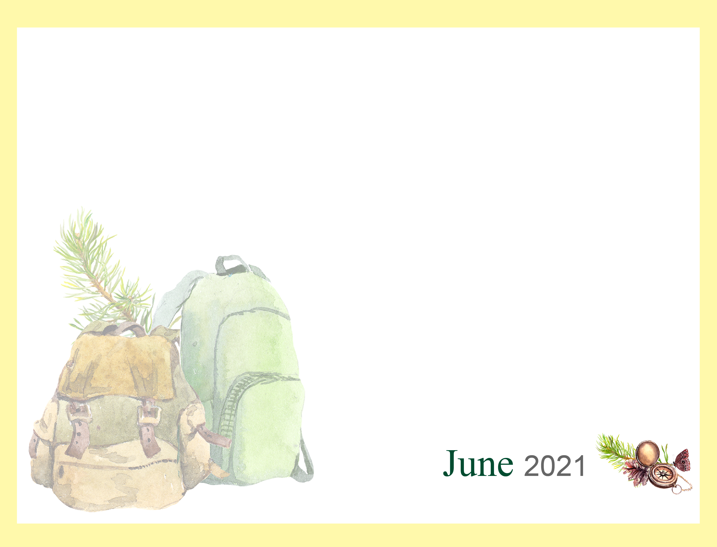
www.stagnesvalpo.org like us on FACEBOOK

